***Name:*** Saif Eldin Abdelwahhab Mohi

***Group :*** 3

***Section :*** 17

***B.N:*** 371

***Topic*** *:* Computer Engineering Role in COVID-19 Pandemic?

***Github link:***

***Github pages link:***

***Source Code :***

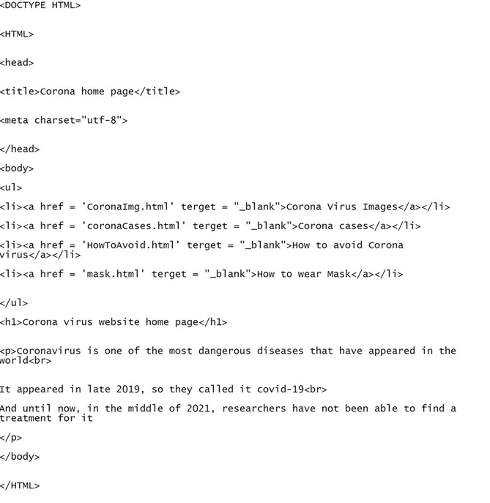

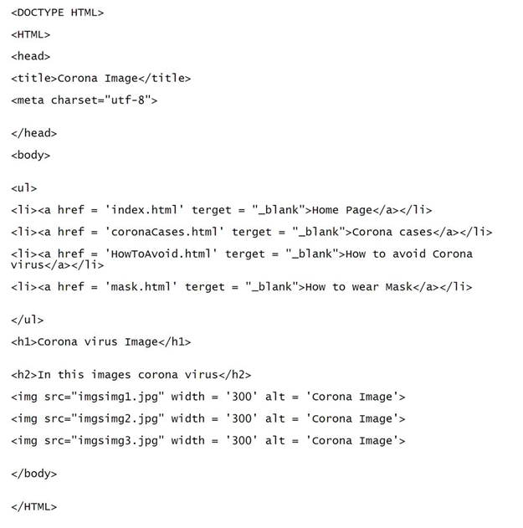

***Screenshots:***

